**Question 1 : Self Diving Numbers**

Output Screenshots:

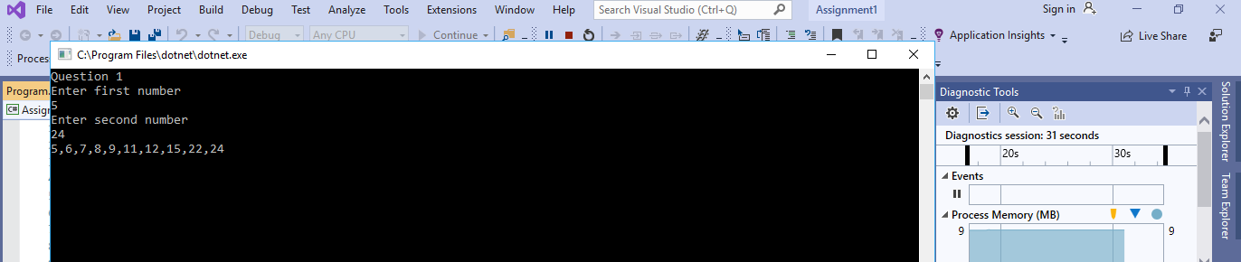

**Question 2**

Output Screenshot:

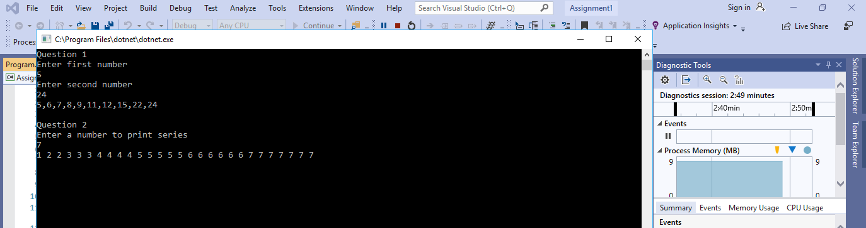

**Question 3**

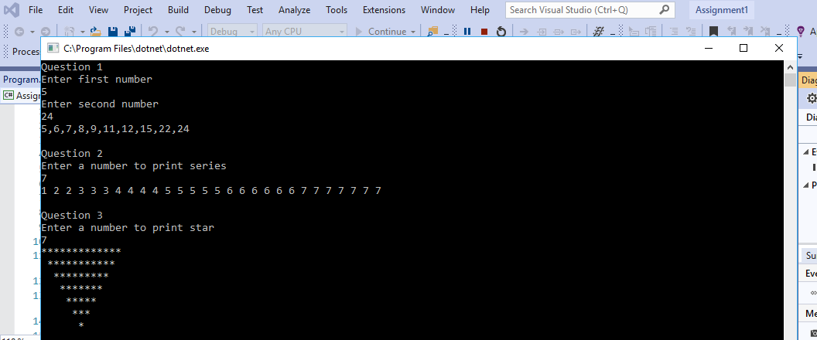

**Question 4: Number Of Jewels**

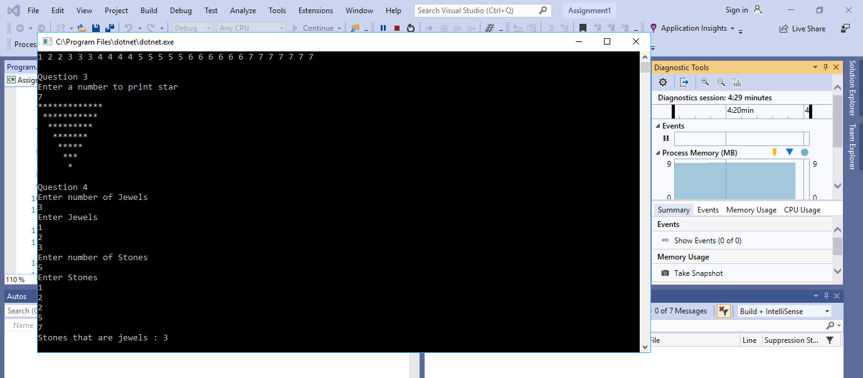

Handled dynamically.

**Question 5**

